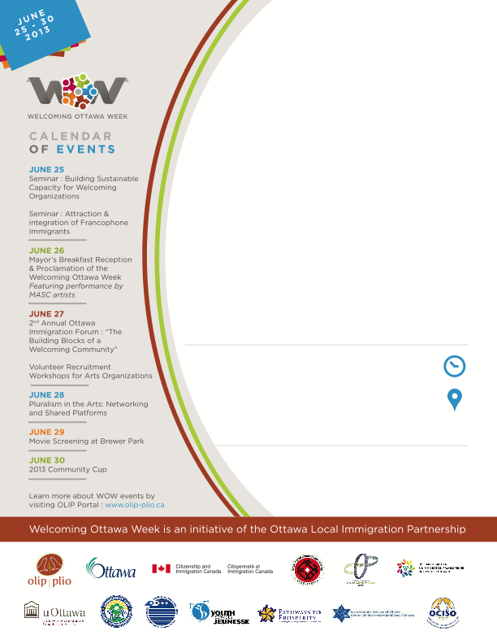

Event title

Additional event information

Additional event or organization description

Venue

Date & Time

Organizer’s logo

Organizer’s name

HOSTED BY