INSERT ORGANIZATION’s LOGO 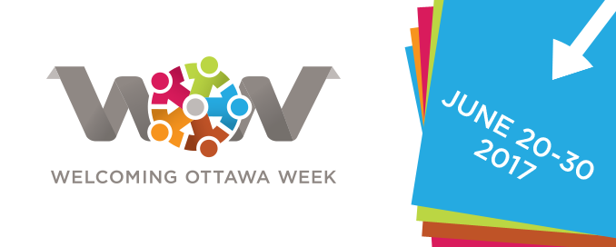

Appendix 2

PUBLIC SERVICE ANNOUNCEMENT / MESSAGE D’INTERET PUBLIC
For Immediate Release
[INSERT YOUR ORGANIZATION’S NAME] to Host [INSERT NAME OF EVENT] as part of Welcoming Ottawa Week

Ottawa (DATE, 2017) – As part of the fifth annual Welcoming Ottawa Week (WOW) [INSERT YOUR ORGANIZATION’S NAME] will be hosting, [INSERT NAME OF EVENT] on [INSERT DATE.]. The goal of the event is to [INSERT THE SPECIFIC GOALS OF YOUR EVENT]

INSERT MORE DETAILS ABOUT EVENT.

“WE ARE PROUD TO ORGANIZATION THIS EVENT BECAUSE XXX”, INSERT NAME OF ORGANIZATION CEO OR KEY EVENT ORGANIZER.

Background

The first WOW was held in June 2013 when Ottawa Mayor Jim Watson proclaimed the last week of June of every year to be WOW, when Ottawa residents could express our genuine welcome to newcomers. “The residents of Ottawa are diverse, and a large majority of us originate from immigrants who came, settled, and contributed to Ottawa’s quality of life”, said Mayor Watson in his WOW proclamation speech. “The Welcoming Ottawa Week will underscore our genuine respect and hospitality to newcomers, while at the same time creating opportunities for dialogue and interactions between newcomers and established residents.”

WOW is an annual, week-long series of dialogues, cultural and celebratory events, sports activities, documentary screenings,
and other fun events, designed to convey the genuine welcome and hospitality of Ottawa residents to newcomers.
It provides opportunities for quality interactions between newcomers and long-time residents. The inaugural 2013 WOW included eight events that showcased Ottawa’s thriving diversity and welcoming spirit. In 2017, the chorus of welcome is a lot stronger, with more than 70 events taking place throughout the city during the Welcoming Ottawa Week: June 20 to 30.

WOW is presented by the Ottawa Local Immigration Partnership (OLIP), founded in 2009 by the City of Ottawa and Local Agencies Serving Immigrants (LASI). OLIP is funded by Immigration, Refugees and Citizenship Canada, with the mandate of improving local capacity to attract, settle and integrate immigrants.

On average, Ottawa attracts 12,000 new immigrants every year and these include permanent and temporary residents, international students and refugees. Immigration is a major contributor to Ottawa’s population and labour force growth. As such, it is now well understood that Ottawa’s economic and social development is in lock-step with its success in welcoming immigrants and facilitating their integration in all aspects of community life.

-30-
For interviews and more details please contact:
ADD YOUR MEDIA CONTACT’S NAME
Email: XX
Phone: XX
SOCIAL MEDIA:

WOW Hashtags: #WOW17, 5SAO17, #Ottawa, #CndImm

Your Event’s Hashtags: ADD YOUR EVENT’S SOCIAL MEDIA INFORMATION.

Ottawa Local Immigration Partnership:
https://www.facebook.com/OttawaLIP
https://twitter.com/OLIP_PLIO
URL: http://www.welcomingottawaweek.ca

