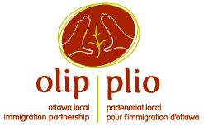

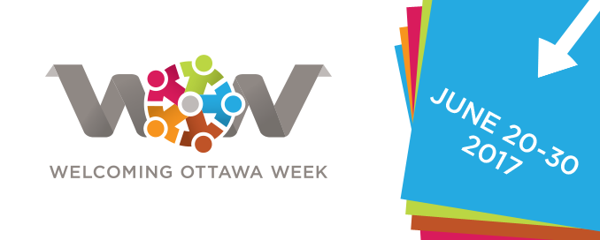

**Appendix 7**

**WELCOMING OTTAWA WEEK (WOW), June 20 to 30, 2017**

**Support for WOW Event Hosts:**

**Hosting, Learning From and Reporting on Events**

Thank you for hosting an event during Welcoming Ottawa Week (WOW) 2017!

As part of WOW, you are contributing to:

* Celebrating Ottawa’s diversity and the contributions of immigrants;
* Providing an opportunity for all Ottawa residents , including immigrants, to connect, creating a cohesive, resilient and vibrant civic culture;
* Enabling Ottawa residents to express their welcome to immigrants, showcase integration successes and discuss challenges.

We anticipate an impressive array of arts and cultural, sporting, educational, community, formal and historical events during WOW17!

**Hosting a WOW Event**

Here are some tips to help make your event inclusive:

* Consider your venue, agenda, logistics, catering, facilitation, promotional materials and communications strategy. Are they designed to be accessible to all? Do they reflect the diversity of the community?
* Are there community centres, immigrant resettlement agencies, ethno-cultural groups or faith-based groups in your community through which you could reach out to invite a diversity of newcomers?
* Is your event date on a religious holiday or a day observed by some of Ottawa’s residents?
* Do you need to have someone on hand to welcome attendees and help them settle in? To help with language interpretation?
* Build in opportunities for participants to get to know about each other, if appropriate.
* Respect the diversity of participants; avoid stereotypes and assumptions.
* For more information on hosting inclusive events, see online toolkits from [CRIAW](http://www.criaw-icref.ca/sites/criaw/files/Inclusive%20Practices%20Toolkit%20(1.0%20-%20Accessible%20Digital).pdf) or [Reconciliation Canada](http://reconciliationcanada.ca/staging/wp-content/uploads/2015/05/CommunityActionToolkit_PlanYourOwnEvent.pdf).

**Providing Feedback to OLIP on Your WOW Event**

We’d like to hear from you about how your event went. This information will help OLIP assess the outcomes and reach of WOW17, and help make next year’s WOW even better.

1. ***During the event:***

* Record the number of participants at your event.
* Have one of your organizing team or a volunteer gather comments, quotes and highlights from the event, if possible.
* Consider asking participants to give you feedback on the event using an evaluation activity or questionnaire. Depending on the type of event you are hosting, you could use, for example, one of the following approaches:

1. **A brief questionnaire or exit survey**

At the event, give participants a brief questionnaire to complete. The questions can be open-ended, for example:

1. What did you enjoy most about the event?
2. What is one suggestion you have to improve the event?
3. What is one thing you learned about immigrants’ integration in Ottawa?

Alternatively, the questions can offer a rating scale, for example:

1. My overall assessment of the event is (1 = needs improvement - 5 = excellent)
2. 2 3 4 5
3. I will use what I learned at this event in my work / life.

Not at all Somewhat To a considerable extent A great deal

1. Through this event, I was able to connect with newcomers and other people in my community

Not at all Somewhat To a considerable extent A great deal

1. **Head-Heart-Feet reflection**

At the end of an event, ask participants to record or share their responses to three questions:

1. Head: After participating in this event, what is one thing you’re thinking?
2. Heart: After participating in this event, what is one thing you’re feeling?
3. Feet: After participating in this event, what is one thing you’re excited about doing?
4. ***After the event:***

Send a summary report to OLIP on your event. We ask that you include:

* A brief description of your event;
* The number of participants at your event;
* A brief description of who attended (e.g. members of the public? specific invitees? service provider organizations?)
* A brief summary of the outcomes of your event and/or participants’ feedback.

We look forward to hearing about your event!

Thank you!

Hashtag: #2017WOW, #2017SAO, #Ottawa, #OLIP-PLIO.

[cid:image001.gif@01CF705D.D9BAA130](https://www.facebook.com/OttawaLIP) <http://www.facebook.com/OttawaLIP> [cid:image002.gif@01CF705D.D9BAA130](https://twitter.com/OLIP_PLIO) <https://twitter.com/OLIP_PLIO>

Website: <http://www.welcomingottawaweek.ca>

**For more information, please contact:**

Hodan Egale

Email: [hodan@olip-plio.ca](mailto:hodan@olip-plio.ca)

Phone: 613-232-9634, ext. 385