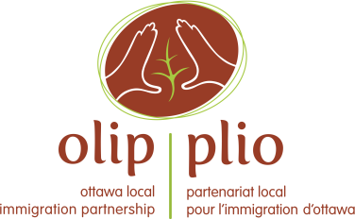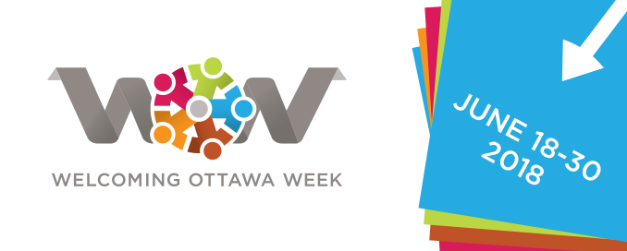
Communications Toolkit – Welcoming Ottawa Week 2018 Events
The goal of this toolkit is to provide Welcoming Ottawa Week (WOW) event organizers with some simple ideas and tools that will help you to publicize your event. Please feel free to pick and choose from the tools provided. We hope that these tools will be helpful in making your event a great success. We truly appreciate the efforts of each and every event organizer in making this year’s WOW the best one ever!
Background on WOW
In its fifth year, WOW takes place from June 18 to 30, 2018. WOW is an annual, week-long series of dialogues, cultural and celebratory events, sports activities, documentary screenings, and other fun events, designed to convey the genuine welcome and hospitality of Ottawa residents to newcomers, while providing opportunities for quality interactions between newcomers and long-time residents.

For more information on WOW, please read the Qs&As (Appendix 1) or visit www.olip-plio.ca.

OLIP’s Communications Support

The Ottawa Local Immigration Partnership provides support to WOW. It has publicized WOW through the development of a communications plan that includes WOW logo, web content (www.olip-plio.ca), messaging, brochures, poster, media relations, social media, and by hosting the WOW launch event. OLIP will produce a calendar of WOW events to be published on its website and in a booklet to promote the events.

Inviting VIPs to your Event
WOW is about civic engagement and showing the welcoming side of Ottawa. Consider inviting your local elected officials (eg city councillor, mayor, MP, MPP) and high profile business people to participate in your event. This could bring additional attention to your event and provide networking and engagement opportunities. You may want to provide an opportunity for the VIP to deliver short remarks at your event and include an opportunity for taking photos with the participants. If you have a banner or special backdrop, use it in the background.

Communications Lead
If you have an organizing committee for your event, try to designate someone as the communications lead who can be the point person for developing the communications materials and engaging other volunteers as needed.
Key Messages
The following are the overarching key messages for WOW:
- Newcomers contribute greatly to Ottawa’s vitality and prosperity.
- Every year Ottawa welcomes about 12,000 immigrants and refugees.
- WOW provides an excellent opportunity to create further bonds between newcomers and long-term residents of Ottawa.
- WOW celebrates Ottawa’s diversity, welcoming spirit and genuine hospitality.
Consider developing three to five short and snappy key messages that are specific to your WOW event. These messages will come in handy to use in promotional materials, speaking notes and media materials for your event.
Qs&As
See Appendix 1 for questions and answers about WOW. If you have additional questions about WOW, please feel free to contact Suzanne Charest at suzanne@olip-plio.ca or 613-232-9634, ext. 318. You can also have a few questions and answers specific to your event.
Media
Consider developing a news release to publicize and invite the public to your event. This public service announcement (PSA) news release would be sent to local media about three to four weeks before your event. It should focus on the 5Ws of your WOW event – who, what, when, where and why. Many community newspapers use ready-made content and some community associations and media outlets have website calendars where they publicize local events. See Appendix 2 for a template PSA news release.
Approximately two to three days before the event, send a media advisory to local media outlets, informing them of the details and inviting them to attend. If you have confirmed VIPs attending, mention their participation. See Appendix 3 for a template media advisory.
Make sure you have a designated media spokesperson for your event. Provide this spokesperson with your key messages, questions and answers and an overview of key highlights of the event that may be newsworthy. See Appendix 4 for media interview tips/tips on what makes something newsworthy.

Promotional Materials
Develop a poster and invitation for your event. Include the WOW logo found at www.olip-plio.ca. Make sure the poster appears on community centre bulletin boards and distribute widely throughout your network.
Social Media
Social media can be a great way to publicize your event. Develop social media content to be sent out at least a few times a week for the month leading up to the event. Depending on your audience, develop similar content for Twitter, Facebook, Instagram and Snapchat. Use the WOW logo and hashtags #WOW18, #SAO18, #Ottawa, #CndImm and tag OLIP @OLIP-PLIO. Share your poster, and any media materials via social media. Encourage members of your event organizing committee to share the content with their social media networks.
During the event, designate someone to live tweet about the event, including photos and interesting quotes or details about the event.
Emails
Develop an email list for people or organizations that are connected to your event. Distribute key information about this event using this list. Encourage everyone to spread the word about the event and include a contact person for questions.
Please upload 7 to 10 of the best photos of your event (in high resolution format) to OLIP’s Flickr page so that these photos can be used by OLIP for future communications tools. Please ensure that you have permission from the photographers and subjects (see below) to share the photos.
Photos
If you hosted an event last year, use any photos from the previous event in your promotional materials. Please ensure that you have consent to use people’s images (especially children) on social media, etc. See Appendix 5 for an example of a photo consent form.
Communications Checklist
To make that you have covered all angles, draft a checklist for your communications tools. See Appendix 6 for a template checklist.
After the Event
After your event, archive your photos and stories. Consider sending an article about the event’s success to your local community newspaper, along with a few quality, high resolution photos. Thank the volunteers and participants via your email list and social media. Complete the WOW information form (see Appendix 7) and send it to OLIP at suzanne@olip-plio.ca.
Questions
Thanks again for participating in WOW and good luck with your event!
If you have questions or additional ideas regarding communications for WOW, please contact Suzanne Charest at suzanne@olip-plio.ca or 613-232-9634, ext 318.

